# Algorithm for file updates in Python

## Project description

This project involves automating the process of updating an allow list of IP addresses for a healthcare company's restricted subnetwork. The task is to remove IP addresses that appear on a remove list, ensuring secure and accurate access control.

## Open the file that contains the allow list

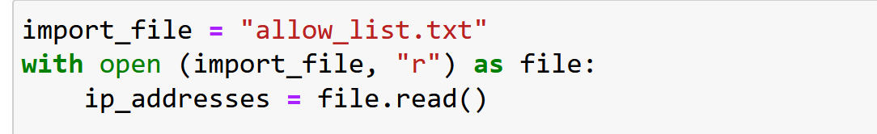

The with statement opens the file named allow_list.txt in read mode, ensuring the file is closed automatically after the operation.

The file.read() method reads the file’s content into a variable.

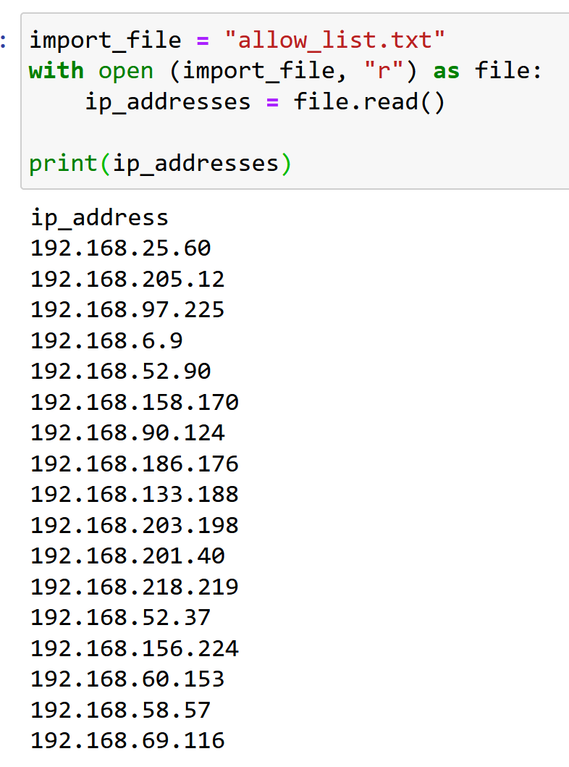

## Read the file contents

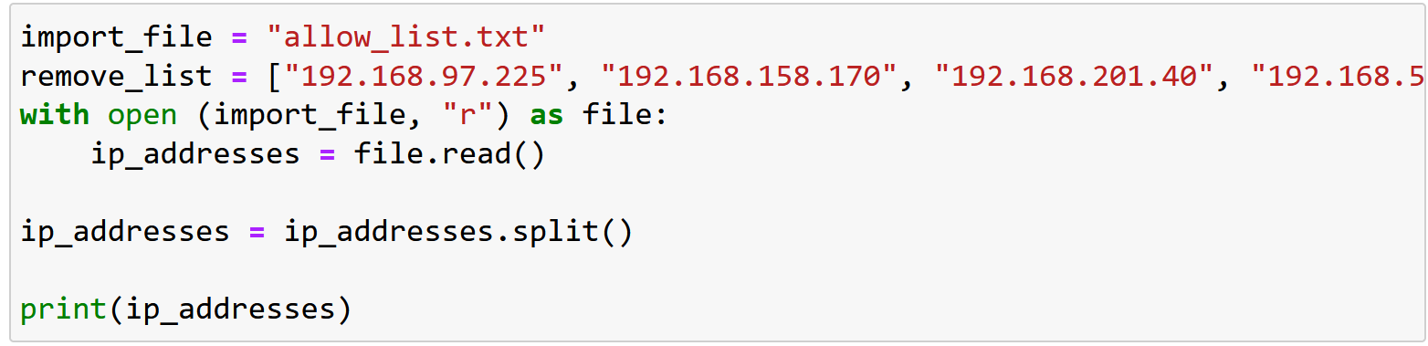

The .split() method converts the file content from a single string into a list of IP addresses, making it easier to process.

## Convert the string into a list

This step is already achieved with the .split() method in the previous step.

## Iterate through the remove list

remove_list = ["192.168.97.225", "192.168.158.170", "192.168.201.40", "192.168.58.57"]

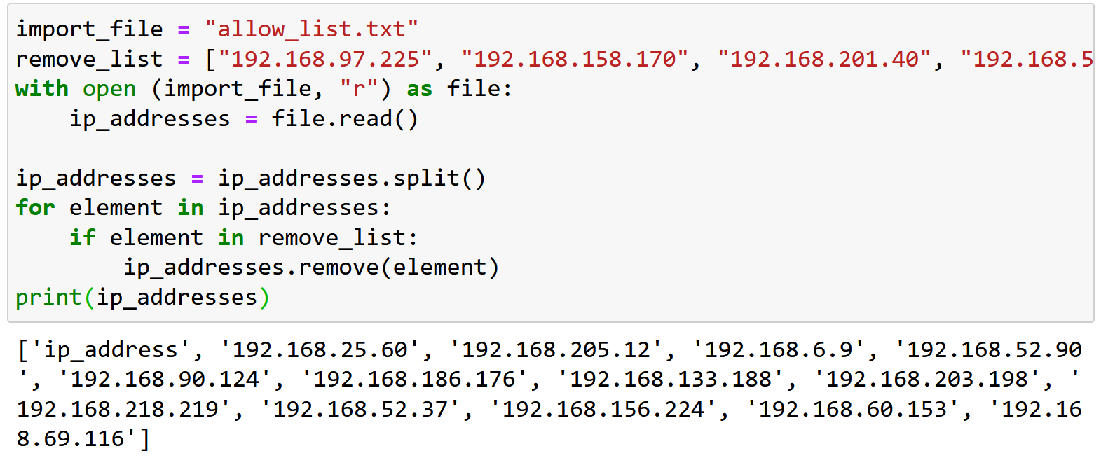

A for loop iterates over each IP address in the allow list (ip_addresses).

If an IP address matches an entry in the remove_list, it is removed from ip_addresses.

## Remove IP addresses that are on the remove list

The removal process is handled within the loop using the list.remove() method.

## Update the file with the revised list of IP addresses

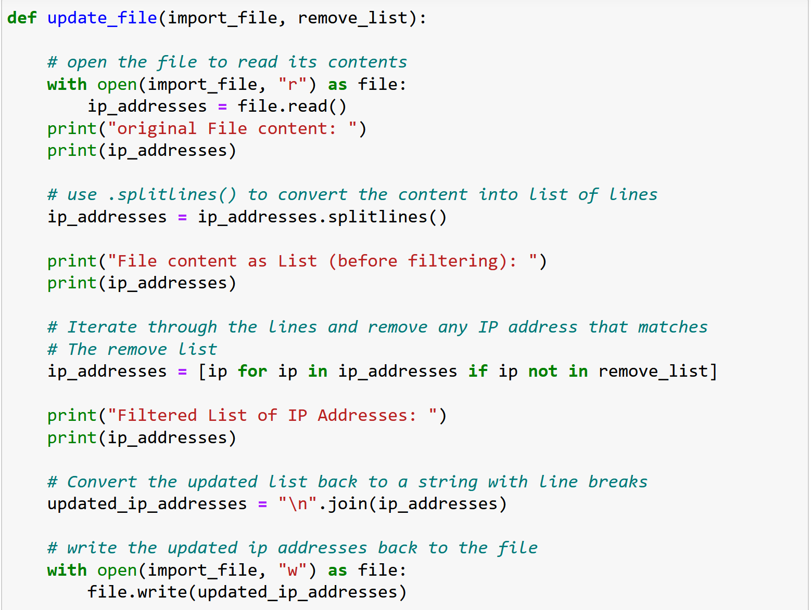

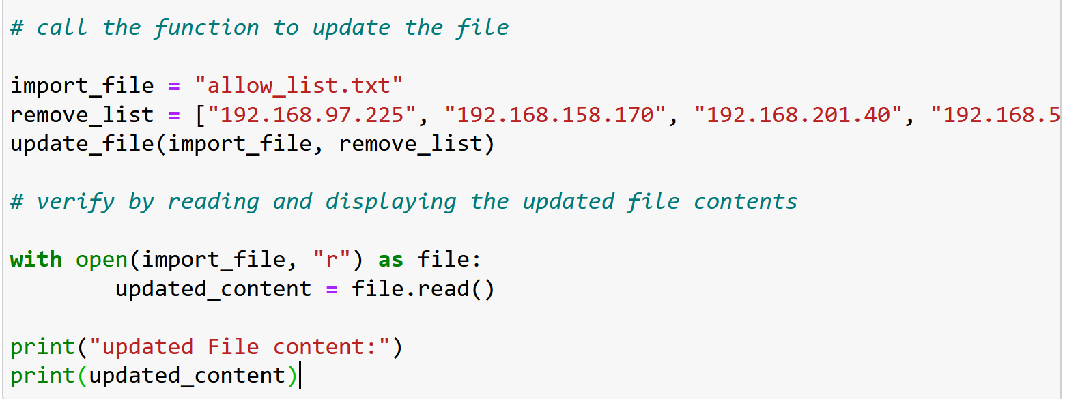

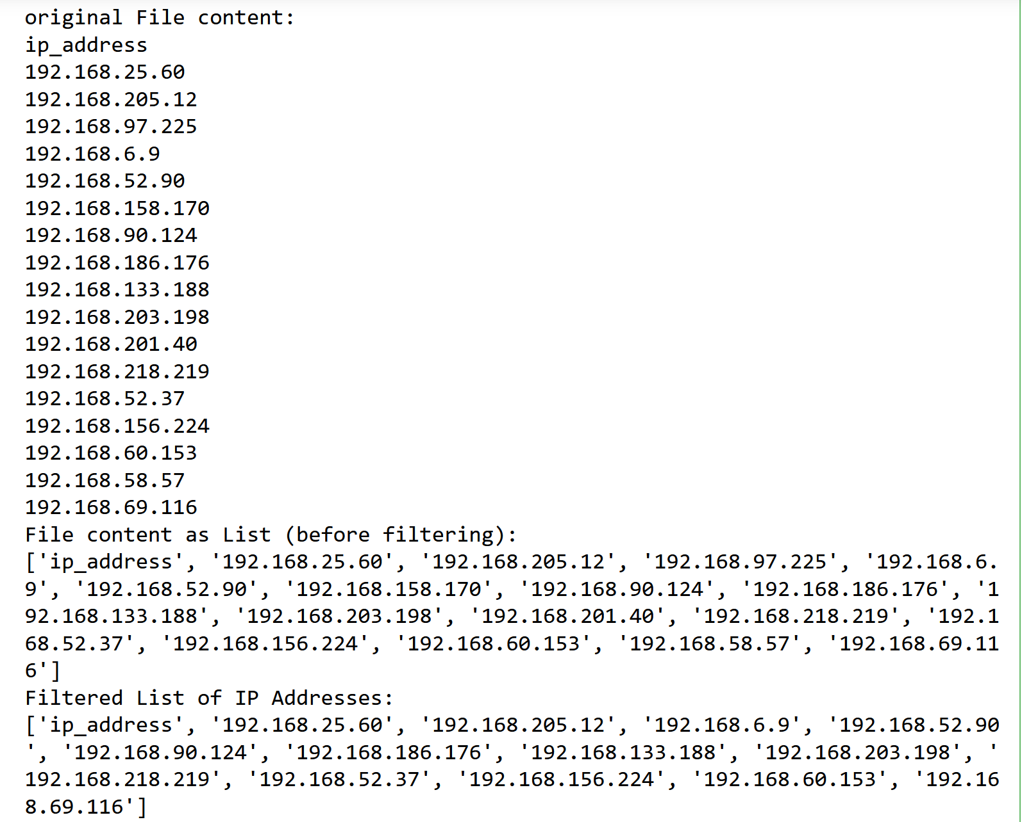

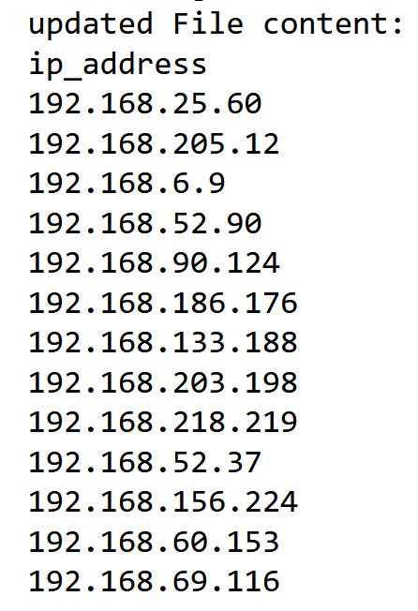

“\n”.join(ip_addresses):

combines all elements of the ip_addresses list into a single string, separated by newline characters (\n), so each IP appears on a new line.

with open(import_file, “w”) as file:

Opens the file in write mode (“w”) to replace its existing content.

Ensures that the file is automatically closed after the writing process is complete.

file.write(updated_ip_addresses):

Writes the new string containing the revised list of IPs into the file, overwriting the old content.

At the end of this step, the allow_list.txt file contains the updated list of authorized IP addresses, ensuring that any restricted IPs have been successfully removed.

## Summary

This project automated the process of updating an allow list by removing authorized IPs listed in a remove list. Using python, we read the file, processed its content to remove restricted IPs, and updated the file with the revised list. This ensures efficient and secure management of network access, demonstrating key file handling and automation skills in cybersecurity.